Actions for this week:
Gain a deeper understanding of several important concepts in my research area and develop a high-level, “big picture” grasp of the field.

What did I do this week? Why did I do this?
I started to self-study more advanced topics in human activity recognition ahead of time, in order to lay a solid foundation for future discussions with my supervisor. I thought about how to build on previous research projects and use them as a basis to improve the quality of my experiments. I reflected on what specific problem I actually want to solve within human activity recognition.

I also considered how to measure model energy consumption, examined whether past experimental results in the literature are reliable, and explored how to make my own work as close as possible to top-conference/journal level. In addition, I learned about new concepts and ideas in the HAR field, thought about how to design a new model, and, after designing it, how to complete the remaining rigorous experiments and use comparative studies to verify the efficiency of my new model.

Outcomes and findings:
I learned many new concepts and ideas in the field of human activity recognition. By repeatedly searching and reading, I now have a rough, high-level understanding of the field as a whole.

Reflection:
At the moment, I still feel like a beginner in this area, and I am very confused about many concepts. Because I have only mastered a small amount of knowledge so far, I don’t yet know exactly what research problem I should focus on, or which research question is suitable for me.

Have I finished this week’s action? What percentage? If not, how to improve?
Completion rate: 40%.
I need to increase my study time and speed up how quickly I absorb new knowledge.

Actions for next week:
Become more familiar with my research area and spend more time studying it in depth, but without needing to understand every aspect in excessive detail.

Detailed thought process:

At the start of the new term, I noticed that my earliest class is on the 26th next week. Last semester, our lecturer Peter said that all of us would be assigned a supervisor. Based on the current situation, I estimate that my first meeting with my supervisor may not happen until late September or early October. In other words, the amount of time during which I can receive direct guidance from my supervisor will be significantly reduced, so I need to fill in more knowledge by myself before that first meeting.

Regarding human activity recognition, I have previously done some related work. However, if I directly reused that work and its code in my individual research project, the quality would probably be quite average. I need to find ways to significantly improve the quality of my research. One approach is to read mainstream and authoritative literature, for example papers from the last three years, or well-regarded survey articles.

In my previous work, I used LOSO Macro-F1 as the main evaluation metric, and I think this can still be kept. The Macro-F1 score treats all classes equally and can reveal the weaknesses of a model on rare classes. With a subject-wise Leave-One-Subject-Out protocol, I would first compute the per-class F1 scores for each held-out subject, then take a macro-average over classes, and finally compute the mean ± standard deviation or 95% confidence interval across all subjects/folds. This approach is more robust to class imbalance and fairer for cross-subject generalisation, and is more trustworthy than a single “overall accuracy” number. In addition, it is best to provide a confusion matrix for each model, so that it is easy to see which activities are often confused with each other.

In my earlier work, the number of models I experimented with was quite limited. For this project, I should choose more strong and comparable models as baselines. In a previous machine learning assignment, one of the marking criteria was “breadth and depth of experiments.” I understand “breadth” as including, for example, the number and quality of datasets, baseline models and evaluation metrics. For this project, I plan to use at least five baseline models, two to three datasets depending on time, and evaluation metrics that cover model accuracy, model size, inference latency and estimated energy consumption. That should satisfy both breadth and depth.

After some investigation, I plan to choose KNN, Random Forest, InceptionTime, MiniRocket and MultiRocket as my baseline models.
This combination covers three key “schools” of time-series classification:

* Classical machine learning benchmarks (KNN, Random Forest), representing the upper bound of “feature engineering”-based methods;
* End-to-end deep learning SOTA (InceptionTime), representing the power of sophisticated CNN architectures;
* Modern feature-transform SOTA (MiniRocket/MultiRocket), which are currently among the hardest baselines to beat, combining high efficiency with strong accuracy.

However, this led me to an important question: what exactly is the research problem I want to tackle in human activity recognition? What problem do I really want to solve? I realised that my previous work was essentially just taking a few models I had learned about—or some mainstream models—training and testing them on a preprocessed dataset, and then reporting the evaluation metrics. This is basically just repeating what others have already done.

Therefore, I need to make a real breakthrough and contribute something original. For example, I could develop a new model, but this new model must show improvements in at least one aspect, such as accuracy, model size, inference latency, or energy consumption.

This was the first potential contribution and point of originality that came to mind, so I began to read journal and conference papers to learn about new models. After studying the literature, I realised that designing a new model would require a lot of effort and time. So for now, I decided to put the concrete model design aside. Instead, I plan to first strengthen the foundation of my work—for example, I did not estimate energy consumption in my earlier experiments, and my dataset preprocessing was not rigorous enough. I want to “build the foundation” properly first, and then consider more advanced steps such as designing a new model.

Regarding energy consumption, I learned that the most authoritative measurements require specialised laboratory equipment. This is the most widely recognised and accepted approach, and it can greatly enhance the quality and credibility of a paper and its experiments. However, given the complexity of operating such professional energy-measurement devices and their high cost, it is clearly impossible for me to purchase them myself.

If I tried to rent equipment from the university, there would be two problems: first, the university may not even have suitable measurement devices; second, even if they do, I would need to spend a lot of time learning how to operate them. So I started to look for alternative devices that are easier to obtain. During this process, I also found via Google that some professional labs can help measure energy consumption, but their service fees start from several thousand US dollars. On top of that, I still haven’t fully figured out how exactly I want to measure energy consumption and which concrete method I should use. In reality, using such professional third-party measurement services is more suitable for research or commercial institutions that specialise in human activity recognition. For a master’s project like mine, using high-end professional equipment seems unnecessary and would be overkill.

I then found a simpler and relatively reliable measurement option: the Raspberry Pi. However, even the Raspberry Pi–based method requires purchasing some hardware, such as a data logger and a power-measurement module. The good news is that the operational barrier is much lower than for laboratory-grade equipment.

So I began to look more deeply into low-threshold yet relatively reliable energy-measurement approaches like those based on Raspberry Pi. But then I suddenly thought: do all researchers really need physical devices to measure energy consumption? Surely some people are in a similar situation to me, without access to professional equipment. How do they handle the problem of measuring energy?

This led me to the concept of *energy proxies*. That is, instead of directly measuring power on the target device or power rail, you use more easily obtainable indicators (such as FLOPs, bytes of memory read/written, latency, or host power-meter readings) to build a mapping that estimates the energy consumption per inference or per task (e.g., mJ/inf, J/task). With this approach, everything can be done using just a laptop, and journals/conferences also accept such methods, as long as you clearly state that it is a proxy measurement rather than a direct physical measurement.

From my reading, I learned that “energy proxy” refers to techniques used to quantitatively estimate the energy consumption of computing components.
For GPUs (graphics processing units), the standard approach is to use NVIDIA’s NVML library to sample their real-time power at a high frequency. By repeatedly running inference tasks in a loop and integrating the collected power data over time, then subtracting the device’s baseline idle power, we can finally calculate the energy required for a single inference (mJ/inf).

For CPUs (central processing units) and DRAM (memory), the main method is to use Intel’s RAPL interface (or AMD’s equivalent). This interface directly provides cumulative energy counters. By reading the counter at the start and end of a task, we can obtain the total energy consumed by that task.

Since I had already decided to use Google Colab as my experimental platform, the next question was whether these energy proxy methods could be implemented on Colab. I found that it is indeed feasible to perform proxy-based energy measurements on Google Colab, especially on the GPU side using NVML as a semi-direct measurement proxy. However, CPU-side RAPL counters are basically inaccessible due to virtualisation and permission restrictions.

I then remembered that many traditional models are often trained on the CPU, such as KNN, Random Forest and MiniRocket. This raised a concern: would it still be convincing to estimate their energy consumption using GPU-side NVML-based proxies? I found that if we use GPU-native implementations—for example, KNN/Random Forest from RAPIDS cuML, or deep models implemented in PyTorch/TensorRT—then most of the computation and memory transfers indeed happen on the GPU, making GPU-based energy proxies more reasonable. At the same time, we can explicitly restrict the reported scope to: relative energy efficiency rankings and trends of different models/hyperparameters on the *same* Colab machine and *the same* GPU, while clearly documenting the sampling period, warm-up procedure, baseline subtraction and number of repetitions.

I also discovered that all six baseline models I want to use have GPU-enabled versions. For example, MiniRocket and MultiRocket both have implementations in sktime and tsai, and the tsai versions can be accelerated with a GPU. However, I need to make sure that the tsai-based configurations match the sktime reference implementation as closely as possible, because sktime is the mainstream reference, and tsai’s PyTorch/fastai implementation is intended to be an equivalent variant.

Energy proxy methods should also be implemented in several different ways; one possible approach is as follows:
No hardware power readings are required; this approach is the most general, but it is quite sensitive to differences in architecture, cache, and frequency scaling.

Dataset preprocessing is a very important part of the experimental environment and can greatly affect the results of both the experiments and the models. In order to make preprocessing more rigorous in my later project, I first plan to carefully re-examine and tighten the preprocessing steps used in my previous work. In the field of human activity recognition, I have previously trained and tested kNN, Random Forest, MiniRocket and TST on the preprocessed PAMAP2 dataset.

I have always been curious about why Random Forest achieved higher accuracy than all the other models, especially higher than the deep model TST. I suspected that there might be issues in the preprocessing pipeline that made the data more favourable to the characteristics of Random Forest. Therefore, under comparable settings, I looked up the kNN and Random Forest accuracy reported in other papers.

Fortunately, compared with the LOSO accuracy reported by Rehman (2024) (RF ≈ 75.7%, kNN ≈ 71.0%), my Random Forest with an 8-second window achieves a Macro-F1 of 0.753, which almost matches their reported accuracy. My kNN Macro-F1 of 0.668 is also in the same order of magnitude as their kNN accuracy of about 71%.

In addition, compared with IMUTube (2020), which also reports LOSO F1 scores, their Random Forest F1 is about 0.70–0.72 (for 8/11 classes), while my Random Forest F1 is 0.72–0.75 (rising slightly as the window length increases). This places my results in the same range, slightly higher in some cases. Overall, this suggests that under a strict LOSO protocol with macro-averaged F1, my pipeline sits at a “reasonable mid-level” compared to existing work.

Rehman, S. U., Ali, A., Khan, A. M., & Okpala, C. (2024). Human activity recognition: A comparative study of validation methods and impact of feature extraction in wearable sensors. Algorithms, 17(12), 556. https://doi.org/10.3390/a17120556

Kwon, H., Tong, C., Haresamudram, H., Gao, Y., Abowd, G. D., Lane, N. D., & Plötz, T. (2020). IMUTube: Automatic extraction of virtual on-body accelerometry from video for human activity recognition. Proceedings of the ACM on Interactive, Mobile, Wearable and Ubiquitous Technologies, 4(3), Article 87. https://doi.org/10.1145/3411841

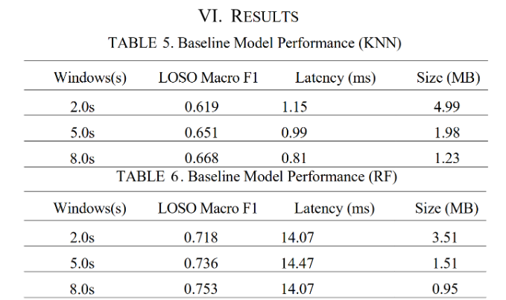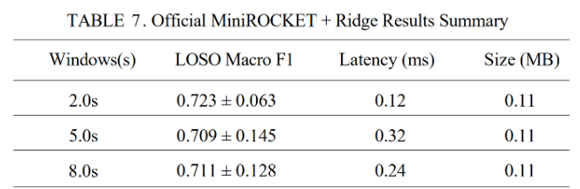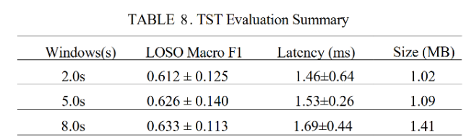

In addition, when I first compared my experiments with other people’s work, I saw that their model accuracies were often 80% or 90%, while my own models looked much lower. This made me worry that there might be something wrong with my experimental pipeline. Later, I realised that because I was using strict cross-subject generalisation and Macro-F1 as the main metric, these two choices avoid a lot of data leakage and suppress inflated scores where the majority class “props up” the overall accuracy. As a result, my scores can easily be 10–30 percentage points lower than results obtained with more relaxed data splits.

I realised that one of the best ways to improve the quality of my experiments is to align my work as closely as possible with top-tier conferences and journals. So I started to compare my previous work against the standards of such venues.

I found that my past work does have some strengths: an end-to-end, reproducible PAMAP2 pipeline covering cleaning, windowing, feature extraction, evaluation and LOSO baselines; jointly reporting latency, FLOPs and model size, together with robustness experiments such as downsampling, channel drop-out and pruning; and some interpretability analyses. These form a solid baseline “skeleton”.

However, there are also clear gaps: my baseline models are not comprehensive enough; I rely on a single dataset; there is a lack of statistical rigour (for example, Friedman + Nemenyi or Wilcoxon tests); and I am missing some advanced experiments such as cross-dataset generalisation, domain adaptation, and self-supervised pretraining.

In addition, I have not yet done multiple random-seed replications, significance testing, systematic and fair hyperparameter search, detailed documentation of data splits and preprocessing to prevent leakage, systematic baselines and ablations, standardised latency and pruning evaluation, or full environment packaging for reproducibility.

I know that the overall quality of my earlier experiments is still far from top-conference/top-journal level, but this raised a question for me. If my experimental quality is only average, how is it that the LOSO accuracies of my kNN and Random Forest models are similar to those reported in previous work? Isn’t that a contradiction—experimental quality below most journal/conference papers, yet results that are comparable?

From my investigation, I realised this is not actually contradictory. I did a reasonably good job on data preprocessing and splitting, on avoiding leakage, and on the basic train/test procedure. Where I fall short is in multiple random-seed repetitions, reporting mean ± variance, significance testing, and various additional advanced experiments. In other words, the *completeness* of my experiments is insufficient.

I then asked myself: if I fill in the gaps by adding stronger and more comprehensive baselines, cross-dataset and cross-domain evidence, confidence intervals and significance tests, proxy-based energy estimates, and then design or improve a new algorithm/model, what differences would remain compared with good journal/conference papers? Based on my reading, I still need to improve in the following areas:

1. The “sharpness and generalisability” of the contribution (whether it is clearly defined and still holds across tasks and domains);
2. The “breadth and depth” of the evidence (time series beyond HAR, measurements on multiple hardware platforms, more systematic robustness and calibration studies);
3. Verifiability and narrative (one-click reproducibility, leak-free design, and transparent reporting of negative results and threats to validity).

In summary, a new algorithm or model *is* a contribution, but it will only be recognised as a substantive contribution if it addresses a clear and important pain point, provides reproducible gains that still hold across datasets and scenarios, and uses rigorous evidence to isolate exactly which part of the method is actually responsible for the improvement.

After all this searching and reading, I felt overwhelmed by the number and complexity of technical terms, and I found them hard to fully understand. So I started to use analogies to help myself. For example, in cooking: running with a single random seed is like cooking a dish only once; using multiple seeds is like cooking it many times, then reporting the average and standard deviation, and performing a paired statistical test. Cross-dataset training—training on dataset A and testing on dataset B—is like learning to cook in one restaurant and then going to another restaurant to serve the same dish to customers. Standardised dataset preprocessing is like carefully controlling key food-safety and hygiene steps, and cutting every ingredient into exactly the right size before cooking.

09.18
Since I currently have plenty of time for the project, my next step is to get a rough picture of the whole field. I do not need to understand every detail yet, but I need a macro-level understanding and a sense of the current progress.

Transfer learning, federated learning, cross-dataset evaluation and cross-domain generalisation all looked quite intimidating at first. I spent some time figuring out the differences between them:

Transfer learning: skills learned on a source dataset/task are fine-tuned on a target dataset/task.
Federated learning: data never leaves the local device; each site trains locally and only the parameters are aggregated.
Cross-dataset: train on dataset A and, without any further training, test directly on dataset B.
Cross-domain generalisation: train in one domain, and the model should work directly on unseen domains/people/devices/scenes.

To deepen my understanding, I used MiniRocket and the PAMAP2 dataset as examples to interpret these four ideas.
Transfer learning: learn “running” from PAMAP2, then use that experience to learn “playing badminton” more quickly.
Federated learning: many people who are unwilling to share their private data collaborate to train a model that is stronger than one trained only on PAMAP2.
Cross-dataset: train on PAMAP2 (Gym A) and see how well it performs on MobiAct (Gym B).
Cross-domain generalisation: train on PAMAP2 (standard gym exercises) and see whether it still works on a construction site (non-standard movements).

I have more or less understood explainable AI (XAI). Its core goal is to increase model transparency: we not only want to know that the model “got the prediction right” (for example, correctly recognising “running”), but also why it believes that. The main XAI methods I looked at are SHAP and LIME. SHAP helps us quantify “which features are most important.” LIME focuses on explaining a single, specific prediction; it perturbs the input slightly (for example, “what happens if I erase the data from the second second?”) and observes how the model reacts.

I realised that, based on my previous work, if I only add more datasets and more baseline models, apply a unified preprocessing pipeline and run a single LoDO (Leave-One-Dataset-Out) evaluation, then without producing new metrics, diagnostics or methods, this is usually more like “engineering improvement / pipeline refinement.” It makes the results more trustworthy, but it is hard to claim this alone as “methodological innovation.” However, this step is a key foundation for turning “engineering” into a genuine “research contribution,” because I already have a complete sliding-window, feature/model pipeline and result aggregation.

I had previously considered designing a new algorithm/model, and I realised that a new algorithm/model needs to be supported by a complete and rigorous experimental workflow in order to fully show its value, for example careful control of training details and robustness tests.

I then organized and summarized a full spectrum of method-innovation types:

New algorithm
Short explanation: innovation in “how to do things.”
Analogy: we already have a “model” (for example, a neural network), but we invent a new, faster “training method” (for example, an optimiser better than Adam) or a new “computational trick” to make it run more efficiently.
Core: focuses on the efficiency or method of the solution process.

New model / new architecture
Short explanation: innovation in the “tool itself.”
Analogy: instead of using the old “CNN” or “LSTM” blueprints, we design an entirely new “component blueprint” (for example, the Transformer and its attention mechanism).
Core: focuses on the structural design of how information flows and is processed.

New paradigm / new problem setting
Short explanation: innovation in “what problem we are trying to solve.”
Analogy: previously, the setting was “give me all the data and I will train” (supervised learning). Now we define a completely new “set of rules,” such as “data cannot leave the local device; training happens locally” (federated learning), or “you only get a few examples but still have to learn” (few-shot learning).
Core: focuses on the definition of the problem, the objectives or the constraints.

New benchmark / new evaluation
Short explanation: innovation in “how we measure performance.”
Analogy: the old “exam” (dataset) was too easy and every model got full marks. We propose a harder and more comprehensive new “exam paper” (such as ImageNet), or a fairer new “marking scheme” (for example, using F1-score instead of accuracy), so that good and bad models can really be distinguished.
Core: focuses on evaluation standards and datasets.

Beyond this, the broader “map” of methodological innovation also includes: problems and paradigms; models and architectures; training and optimisation methods; inference and test-time techniques; theory and analysis; data, evaluation and metrics; systems and efficiency; security, privacy, fairness and social impact; and tooling and reproducibility.

I identified some new models and improvement strategies that I could potentially try, but as I dug deeper, I found that similar ideas and directions are already being pursued by others. This made me wonder whether the following situation can happen: two people work on similar directions and obtain similar results, but one publishes earlier, and the other, who submits later, loses the chance of acceptance. I suspect that producing research outputs is also a race against time.

I also found that strong journal and conference papers do not necessarily overturn the entire field; often they “only” solve relatively small, detailed technical problems. This made me realise that I need to narrow my research focus even further.

As mentioned earlier, if I follow my original plan of designing a new algorithm/model, I need to pair it with a complete and rigorous experimental workflow. I now understand more about what such a workflow includes. For example:

Pose/orientation invariance: using physically consistent rotation augmentation, transformations into a body-centric coordinate system, or quaternion representations to significantly reduce performance collapse caused by changes in sensor wearing orientation; unifying units and sampling rates; and many other details that go far beyond these examples and also need to be carefully handled.

09.19
In order to understand more systematically what counts as innovation and methodological contribution, I did a deeper search and came to some conclusions. I summarised twelve types of innovation/contribution and used cooking analogies to help myself remember them:
problem and setting (inventing a new cuisine),
data and benchmarks (good ingredients plus blind-tasting standards),
representations and retrieval (prepping ingredients and managing the pantry),
model architectures (a new stove or new pan),
objective functions and learning paradigms (seasoning, marinating and workflow),
optimisation and training tricks (controlling the heat, knife skills, order of cooking),
inference and usage stage (plating and serving rhythm),
efficiency and deployment (energy-saving stoves, takeaway packaging, portable burners),
safety, ethics and governance (food safety and allergen labelling),
explainability and scientific understanding (flavour chemistry and blind tasting),
systems and engineering (kitchen pipelines and supply chains),
applications and human factors (restaurant formats and service processes).

I also found that a journal or conference paper does not need to innovate in every one of these aspects. Often, a single strong and clearly defined core contribution is enough, as long as it is important, verifiable and supported by complete evidence. Piling up many small tweaks without a clear main storyline can actually hurt the paper.

I found two journal/conference papers and studied their strengths. Their experimental coverage is quite broad: for example, they use six HAR datasets and report gains of about 1–3% over their respective baselines. Their ablation studies are thorough: they compare different values of lambda, different insertion layers, and use the Pearson correlation coefficient (PCC) to analyse channel correlations. Their methods and novelty are also quite good. However, their data splitting is based on a 7:1:2 random split (instead of strict cross-subject splitting), which is weaker than the strict cross-subject protocol I used before. In this respect, I actually did better than they did.

I learned that, if time and energy permit, including a Dataset Card and Model Card in the dissertation is a very good option. They do not require any extra experiments; they are mainly for explaining what each dataset is, where it comes from, how it is processed, and for describing the model’s purpose, evaluation methods and efficiency. This kind of documentation is flexible: it can be included in the dissertation, published on GitHub, and some journal/conference papers also do this.

I also studied domain adaptation and test-time adaptation (TTA). Simply put, it asks me to do three things:

1. Introduce an “adapt while in use” mechanism (TTA):
Traditional models are static at deployment (inference) time.
TTA methods (such as TENT/EATA) allow the model to slightly update a small subset of its internal parameters (usually only the batch normalisation layers) in real time when it encounters new data during inference. This means the model can “self-calibrate” to the current input environment.

2. Set up an advanced “source-free” scenario:
Assume you cannot access the original training data (source-free, for example due to privacy reasons). You can only use the pretrained model you already have and adapt it to new users (cross-subject) or new environments using the TTA methods mentioned above. This is a very realistic and challenging setting.

3. Verify the gains in “worst-case” conditions:
Under harsh conditions that you have already designed, such as downsampling (data becomes sparser) or sensor drop-out (data becomes incomplete), test whether TTA can act as an “emergency kit” that performs better than a non-adaptive model.

In one sentence: you need to show that your model not only has strong base performance, but can also use a lightweight technique such as TENT to handle sensor failures or data shifts from new users, by adapting in real time without accessing the original training data.

My understanding is that this can be regarded as training and testing the model under extreme conditions, for example when the sampling rate is reduced from 100 Hz to 25 Hz.

I have roughly understood the differences among cross-dataset zero-shot, cross-dataset TTA (test-time adaptation, unlabeled), and cross-dataset few-shot fine-tuning:

All three describe different strategies for “how to use a model trained on one dataset (source domain A) on another different but related dataset (target domain B).”

Their main differences lie in whether the model is allowed to see data from the target domain B, and whether it is allowed to see labels (ground truth answers).

1. Cross-dataset zero-shot
Meaning: “taking the exam cold.”
Mechanism: After the model is trained on A, it is directly tested on B. The model does not update its parameters in any way and is not allowed to “peek” at any data from B beforehand (neither inputs nor labels).
Core idea: It purely tests the generalisation ability the model learned during training.

2. Cross-dataset TTA (test-time adaptation, unlabeled)
Meaning: “adapting while taking the exam.”
Mechanism: After the model is trained on A, when it is run on B for inference (testing), it uses the input data from B (without labels) to slightly adjust a small subset of its parameters in real time (usually the statistics in batch normalisation layers).
Core idea: Without using labels, it exploits the distributional information of B to perform unsupervised self-calibration and adapt to the “style” of B.

3. Cross-dataset few-shot fine-tuning
Meaning: “cramming with a short tutoring session before the exam.”
Mechanism: Before formally testing on B, the model is given a very small amount of B’s data with true labels (for example, five samples per class). The model uses these “correct answers” to run a few gradient descent steps and update its weights.
Core idea: It uses a small supervised signal to quickly correct the model’s bias and tailor it specifically to B.

One-sentence summary of the differences:
Zero-shot: do not change the model, just apply it directly (rely entirely on prior knowledge).
TTA (unlabeled): change the model, but only by using unlabeled data during inference for self-adaptation (adapt to the new environment/style).
Few-shot fine-tuning: change the model using a small amount of labeled data before inference (adapt to the specific rules of the new task).

To understand non-parametric statistical tests for comparing multiple models across multiple datasets, such as Friedman + Nemenyi, Wilcoxon, or Critical Difference (CD) diagrams, I searched for some related figures on Google and learned what they mean. The more models and datasets included, the more informative and effective these methods become.

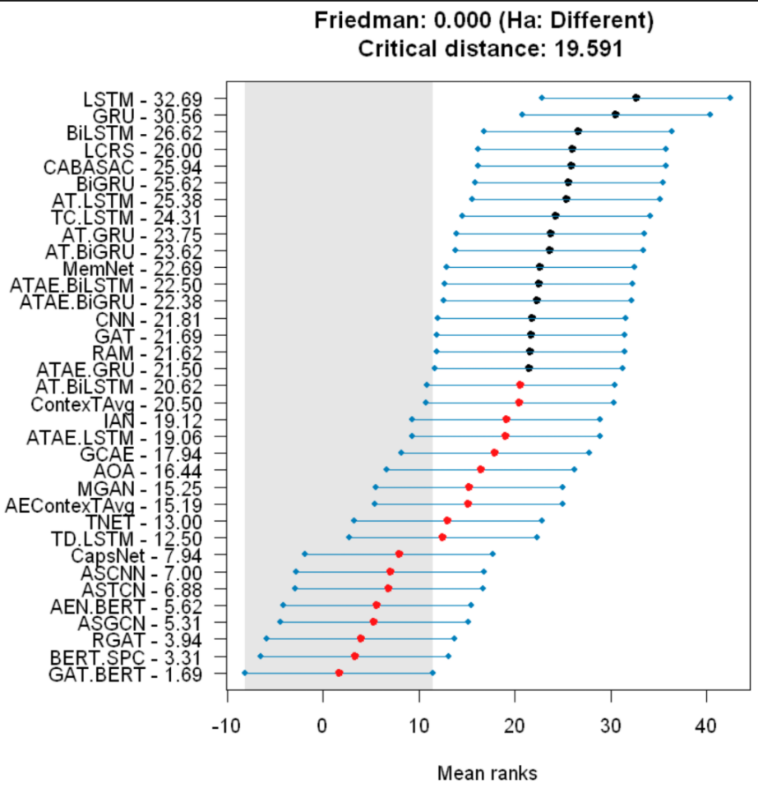
For example, the figure above performs statistical significance comparisons on the performance of multiple models across multiple datasets.
Put simply, it answers: “Which model is ranked first? Which performance gaps between models are real, and which are just due to luck?”

1. The further left, the better (mean ranks):
The x-axis represents the mean rank. The smaller the value (the further left it is), the higher the model ranks across different tests.
Champion: GAT.BERT (the bottom model), with a mean rank of 1.69, performs the best.

2. Colours and grey regions (statistical groupings):
Red points / grey region: these usually represent the “first tier.” This means that although GAT.BERT is ranked first, other models within this region (such as BERT.SPC and the other red-point models) may not be significantly different from it in a statistical sense (that is, their differences may fall within the margin of error).
Black points: the performance of these models is considered, at the chosen confidence level, to be significantly worse than that of the first tier.

3. Horizontal lines (critical distance):
The horizontal lines extending from each model indicate the critical distance interval. If, on the x-axis, the intervals of two models overlap or the distance between their central points is smaller than the critical distance stated in the title (Critical distance: 19.591), then they are considered not to differ significantly in statistical terms.

In summary, this figure shows that GAT.BERT is the SOTA (state-of-the-art) model. It not only has the best numerical performance, but is also statistically significantly better than most of its competitors (those marked with black points).

In addition, I learned about other metrics for comparing the performance of multiple models across multiple datasets, such as Normalized MAE. Fortunately, these comparisons can all be implemented in Python on Google Colab. This means I can incorporate these comparison methods into my later experiments.
As it turns out, I have indeed done so (note added on Tuesday, 11 November 2025).

I also learned that in journal and conference papers, simply listing the accuracies of multiple models in a table is usually not convincing enough. The best practice is to start from a clear experimental design and then present the results together with statistical significance tests, effect sizes and visualisations (such as CD plots, confidence intervals and difference plots).
Fortunately, these can all be computed in one go in Google Colab using Python.

I now understand that in my own work, if I plan to use at least four models and two datasets, I can also run Friedman + Nemenyi, Wilcoxon or Critical Difference analyses in Python on Google Colab. This is very encouraging.

09.20
I suddenly realised that if I plan to design a new algorithm/model, I need a clear way of thinking about how to do it. Should I browse recent effective algorithms and combine their strengths? Or should I transplant successful methods from other fields into my current domain? Or follow the hypotheses proposed by other authors in their papers, breaking down and recombining existing effective methods? Or perhaps use some other approach that I have not thought of yet?

After some investigation, I have a rough idea: the design process should not pursue “newness for its own sake.” Instead, I should first look at where the current SOTA (state-of-the-art) model fails. For example, I can run a SOTA model, plot the confusion matrix, find the classes it cannot distinguish well (such as confusion between “stairs up” and “stairs down”), and then design modules specifically to tackle this weakness.

Another idea is cross-domain adaptation. Computer vision (CV) and natural language processing (NLP) are usually 1–2 years ahead of time-series (HAR) research. I can look at what is currently popular in NLP and then transfer the core architectural ideas (inductive biases) into my own field.

However, I need to be careful not to simply add one or two common modules (such as CNN/TCN/InceptionTime) unless they actually change the Pareto frontier or introduce a genuinely new mechanism.

Moreover, even if I do manage to design a new algorithm/model, I will still have to implement everything myself: the full experimental pipeline, and all the evaluations of its accuracy, efficiency and so on. And there is no guarantee that it will outperform existing methods.

I learned about the concepts of self-supervised pretraining (SSL) and source-free domain adaptation (SFDA), as well as unlabeled sliding windows, the absence of class labels, and Pareto curves.

I also learned about the NeurIPS/ICLR reproducibility checklist. For NeurIPS, it is a checklist submitted together with the paper, placed after the references and before the appendix. It covers whether the claims and limitations are clearly stated, whether data and code are released, how to reproduce the experiments, and so on. For ICLR, it is usually a reproducibility statement that points to reproducible details in the main text, appendix or supplementary materials, as well as anonymous code links.

I studied calibration metrics (ECE, NLL, temperature scaling), time-series classification, monotone coverage, accuracy–rejection curves, conformal prediction, and time-series classification again in that context.

I realised that if I conduct further experiments in the future, I could include some of these elements, as long as conditions allow. But then it occurred to me that each of these additions seems useful, and if I try to include all of them, the work will become too large and too scattered, while my time and energy are limited. So later on I will need to be selective and add only what is most necessary.

I also learned more about SFDA (source-free domain adaptation). It assumes that the source domain is labelled (supervised training is done there first), while the target domain is unlabeled during adaptation, and no source-domain data can be accessed at adaptation time. The model is updated using only unlabeled target-domain data. In addition, training only a lightweight adapter is not a mandatory requirement for SFDA.

Previously, when I ran my code, the output cell showed “Val Loss”. I had forgotten what this concept meant and needed to review it. Its meaning is: using a batch of data that does not participate in training to measure the model’s current error level. The smaller the value, the better the model is fitting “unseen data” at that moment.

